PHASE 5: Deployment & Update Set Management
1. Objectives
- To prepare the completed project for deployment.
- To move the completed configuration from the development environment to another environment.
- To complete the Project Update Set.
- To export the completed Update Set in XML format.
- To make the solution reusable and transferable for future use.
2. Activities Performed
Activity 1: Complete the Update Set
- Go to All → System Update Sets → Local Update Sets.
- Open the Project Update Set.
- Change the State from In Progress to Complete.
- Click Save.
Activity 2: Export the Update Set
- Open the completed Project Update Set.
- Under Related Links, click Export to XML.
- The Update Set data will be downloaded in XML format.
- The downloaded XML file can be shared through email or other supported methods.
- The exported Update Set can be transferred to another ServiceNow environment.
3. Expected / Produced Output
- Project Update Set successfully changed to Complete.
- Update Set successfully exported in XML format.
- All project configuration is packaged into the Update Set.
- The XML file is available for transfer to another environment.
- The completed solution is ready for deployment and reuse.

4.FlowDiagram – 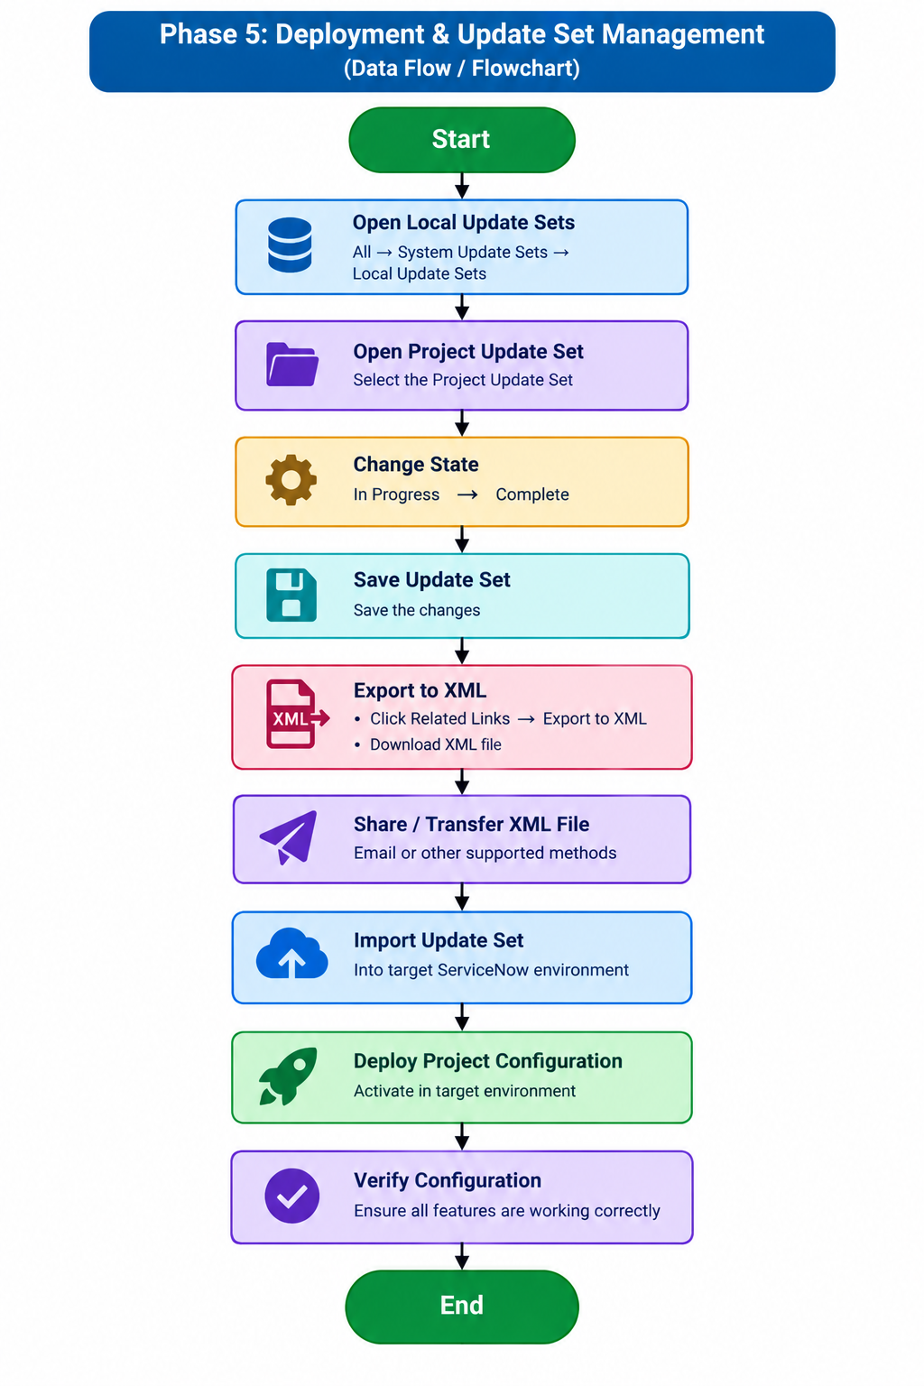DataFlow:
Project Update Set → Complete State → Export to XML → XML File → Target Environment → Deployment → Verification.

